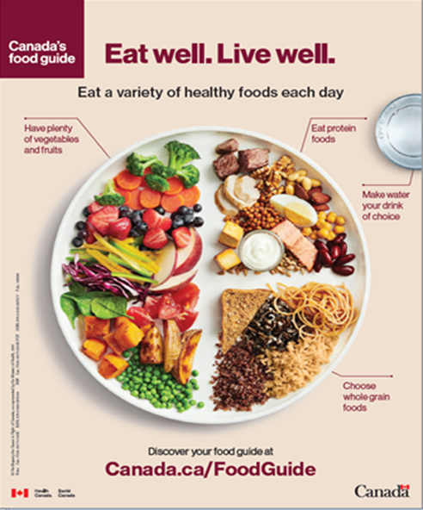
March is nutrition month. Last year’s theme, “Unlock the Potential of Food”, was so good its back again!

This is an ideal time to learn more about healthy eating using the new Canada’s food guide!

There is a focus on eating a variety of healthy foods each day, having plenty of vegetables and fruit, eating protein foods - choosing plant-based proteins more often, choosing whole-grain foods and picking water as your drink of choice.

The guide also highlights the importance of not just what you eat but when, where and why you eat. This includes:
- Eating meals with others
  - Take time to eat
  - Notice when you are hungry and when you are full
- Cooking more often
  - Plan what you eat
  - Involve others in planning and preparing meals
- Enjoying your food
  - Culture and food traditions can be a part of healthy eating
- Being mindful of your eating habits

These are all help to build a healthy relationship with food.

For more information head to: www.Canada.ca/FoodGuide

The new food guide also comes with many recipes! Try this one tomorrow!

Good morning egg roll-up

1 egg or 2 egg whites
30 mL (2 tbsp) diced red bell pepper
30 mL (2 tbsp) grated zucchini or carrot
Pinch fresh ground black pepper
1 small whole grain flour tortilla
15 mL (1 tbsp) grated light old Cheddar or Swiss cheese

- In a small bowl with a fork, beat together egg, red pepper, zucchini and pepper.
- Spray a small 20 cm (8 inch) nonstick skillet with cooking spray and place on medium heat. Pour egg mixture into pan, swirling pan to coat evenly. Let cook for about 2 minutes or until edge is light golden. Using a spatula, lift around edges and flip egg over and cook for another 30 seconds or until set and light golden.
- Slide egg onto flour tortilla and sprinkle with cheese. Roll up and enjoy!

Source : https://www.canada.ca/en/health-canada/services/canada-food-guide/tips-healthy-eating/meal-planning-cooking-healthy-choices/recipes/good-morning-egg-roll-up.html

